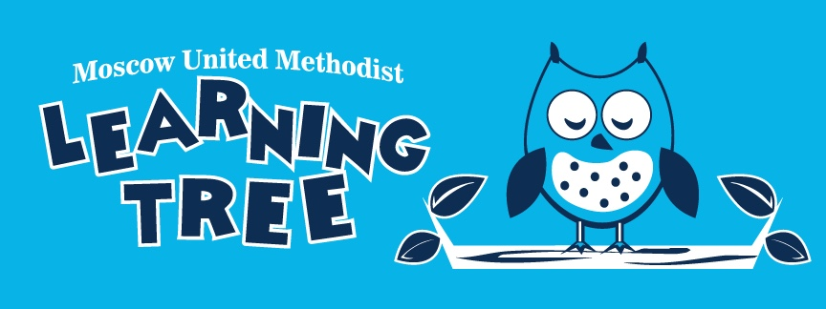

____________________________________________________

Parent Handbook

____________________________________________________

Director/Teacher: Amy Pope 126 Church Street
Assistant Teacher: Melissa Pelligrino Moscow, PA
Phone (570) 871-0351 18444

Mission:
To provide an affordable, quality early childhood education that prepares children for successful academic experiences, in a safe, loving, and nurturing environment. Our programs help children develop emotionally, socially, intellectually, morally, and physically while also providing support and stability for families.

Admission and Enrollment:

The following forms are required for enrollment:
- Pre-K/Preschool Enrollment Contract
- Student Information Form
- Copy of current immunizations
- $25 Registration Fee

*THERE IS A $25.00 REGISTRATION FEE REQUIRED TO HOLD YOUR PLACE IN ONE OF OUR PROGRAMS.

Tuition Rates / Days / Times:

Pre-Kindergarten Program: 4-5 year olds
AM class option (M, W, F, 8:45am -11:30am) = $837.50 per semester
Full Day class option (M, W, F, 8:45am - 2:30pm) = $1,250 per semester

Preschool Program: 3-4 year olds
(T, Th, 8:45am - 11:00am) = $600 per semester

Payment Options:

- Options available to pay- year in full, per semester= 9/1, 2/1, or quarterly= 9/1, 11/1, 2/1, 4/1
- 5% discount for MUMC members
- 5% discount for multiple children (siblings) enrolled in any of the programs
- 5% discount for military families
- MAXIMUM OF 10% DISCOUNT PER FAMILY

*$25 non-refundable registration fee is taken off first payment

The Responsive Classroom Approach:

This approach to teaching and learning has grown out of the work of Northeast Foundation for Children. Their mission is to help schools become caring communities in which social and academic learning are fully integrated throughout the school day, and in which students are nurtured to become strong and ethical thinkers.

The following are seven beliefs that underlie the Responsive Classroom Approach:
- The social curriculum is as important as the academic curriculum.
- How children learn is as important as what children learn.
- The greatest cognitive growth occurs through social interactions.
- There is a set of social skills that children need in order to be successful academically and socially.
- Knowing the children we teach is as important as knowing the content we teach.
- Knowing the parents of the children is as important as knowing the children.
- Teachers and administrators must model the social and academic skills which they wish to teach their students.

Further Reading:
- These seven principles of The Responsive Classroom are further defined in Time to Teach, Time to Learn: Changing the Pace of School by Chip Wood

Discipline:

- The use of Logical Consequences is a discipline technique used in many classrooms. It is a way of responding to misbehavior that is respectful of children and helps them take responsibility for their actions. The primary goal of logical consequences is to help children develop inner control by looking closely at their own behavior and learning from their mistakes.
- Logical Consequences are:
- Related
- Respectful
- Reasonable
- Some examples of Logical Consequences are:
- Making reparations “you break it-you fix it.”
- Mishandling responsibility- more limits are set
- Time-out used in a matter-of-fact and respectful manner NOT as a punishment

Further Reading:
- For further reading on Responsive Classroom Management, Teaching Children to Care: Management in the Responsive Classroom by Ruth Charney
Health and Safety Practices:

HAND WASHING: Children will wash hands after bathroom use and after nose blowing or wiping.

TOYS AND EQUIPMENT: Toys and equipment will be sterilized as needed by the staff of the MUMLT Preschool.

SOILED CLOTHING: Please send in an extra outfit with your child daily in his/her backpack just in case of an accident. If a urine accident should occur, your child should be able to retrieve his/her spare outfit and change out of their soiled clothes. All soiled clothing will be put in a plastic bag for the parent to launder. If your child has had an accidental bowel movement, you will be called to either come and change and clean up your child or take them home (depending on the nature of the accident).

ACCIDENTS AND INJURIES: In the case of an accident or injury occurring at school, the parent or guardian shall be notified by phone. In case of an emergency, the staff shall call 911 first and then notify the parent or guardian. (See MEDICAL EMERGENCIES)

RELEASE OF CHILDREN: Children will absolutely not be released to anyone except those authorized to pick up the child on the enrollment form. Identification is required of those authorized but not familiar to the staff. In the event that you wish another adult to pick up your child, it would require written permission in advance or a phone call to verify personally. Please keep in mind that we only have your child’s safety and wellbeing in mind. There will be no daily snack time with AM Pre-K, Preschool, and Parent/Child Workshop considering we are very limited with our time and would like to spend it learning! If your child has a birthday while at school, we will sing “Happy Birthday” to them as a class and they are welcome to bring a snack/treat/etc. to pass to their friends to take home. This is optional and not required.
Please do not bring toys to play with from home. We have so much for them to play and learn with at school. The doors to the preschool will be locked during school hours for the safety of all of our children. All visitors must ring the intercom to the right of the preschool doors to speak with the preschool staff.

Wellness Policy:

- If your child exhibits signs of illness while at school, it will be determined if the symptoms indicate the need for exclusion until remedied. In the event that your child becomes ill and needs to be picked up, he/she will be separated from the other children until a parent or guardian arrives.
- Your child will not be allowed to attend MUM Learning Tree Preschool if they exhibit symptoms for exclusion within a 24 hour period prior to the child’s admittance back to school. These symptoms include but are not limited to:

  - Fever
  - Diarrhea
  - Vomiting
  - Eye Discharge or Pink Eye
  - Lice or Nits

Medical Emergencies:

IN THE CASE OF A MEDICAL EMERGENCY, THE STAFF AT MOSCOW METHODIST LEARNING TREE PRESCHOOL SHALL FIRST CALL 911 AND THEN NOTIFY THE PARENT OR GUARDIAN.

Inclement Weather:

In the event that the Moscow Methodist Learning Tree Preschool should have to close or delay due to inclement weather or any other emergency, you will be notified by email. The MUMLT Preschool follows the North Pocono School District’s closing policy. If the North Pocono School District closes due to inclement weather, the preschool wil also be closed. If the school district should have an early dismissal due to inclement weather, the preschool will also close after the AM classes re-K class at 11:30am.

**IN THE EVENT THAT THE NORTH POCONO SCHOOL DISTRICT IS ON A TWO HOUR DELAY, THE PRESCHOOL WILL OPEN AT REGULAR TIME, THERE IS NO NO EARLY DROP-OFF.

Please check your emails daily.

Closings will be posted three different ways:
- Email
- News Station WBRE TV
- Moscow United Methodist Learning Tree Preschool Facebook Page

Daily Schedule:

AM Pre-K and Preschool:
- Arrival- Small group Learning Centers/Free Play
- Morning Meeting
- Calendar and Weather
- Table Work- Guided Discovery/Math/Language Arts/Small Group Work
- Carpet Time- Computer/Smartboard/ Music and Movement
- Table Work- Craft/Science/Social Studies
- Whole Group Read Aloud
- Closing Meeting/Dismissal

Full Day Pre-K Schedule continues:
- Lunchtime
- Outdoor (weather permitted) Recess/Music and Movement
- Rest Time
- Small Group Learning Centers/Free Play
- Snack Time
- Enrichment Activities- Math/Science/Social Studies/Language Arts
- Whole Group Read Aloud
- Dismissal

Parent/Child Workshop:
- Arrived- Whole Group Free Play
- Circle time- Hello song
- Mini Lesson
- Whole Group Read Aloud
- Craft
- Music and Movement

Supplies:

- Please send your child to school with a backpack for all the fun things we do at school and important papers we send home. Full Day Pre-K will be required to bring a lunch, drink, and an afternoon snack.
- Please also pack an extra outfit (including undergarments or a pull up) just in case of an accident or emergency.
- The preschool will supply your child with a folder that we require to go home and come back to school daily. Please check your child’s folder daily for important information.

